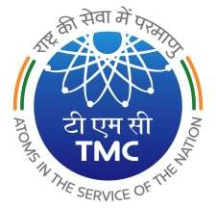

**TATA MEMORIAL CENTRE TATAMEMORIALHOSPITAL**

**(A Grant-inAid Institute under Dept. of Atomic Energy, Govt. of India)**

**CENTRAL PURCHASE UNIT DR. E. BORGES MARG, PAREL, MUMBAI 400012**

11/04/2025

c

GeM Tender Notice No.05

Sub: Tender floated on GeM Portal.

Please visit GeM website [www.gem.gov.in](http://www.gem.gov.in/) for following tender:

|  |  |  |  |  |  |  |
| --- | --- | --- | --- | --- | --- | --- |
| **Sr.**  **No.** | **Description of the item** | **Qty.** | **GeM Bid No.** | **EMD in Rs.** | **Bid End Date and Time** | **Bid Opening date &Time** |
| **1.** | **Bone Mineral Densitometry** | **01 No.** | **GEM/2025/B/6128470**  **Dt: 11.04.2025** | **92,000/-** | **13.05.2025**  **Up to 12.00p.m.** | **13.05.2025 from**  **12.30 p.m. onwards** |

Pre-Bid:-

Date: 21.04.2025 at 11:00 a.m.

Venue: TMH, Central Purchase Unit, Main Bldg. Basement, Parel Mumbai,400012.

OFFICER IN-CHARGE